

**Princess Sumaya University for Technology**

King Abdullah II Faculty of Engineering

Computer Engineering Department

*Embedded Systems & Microprocessors*

ROMOB

*Second Semester 2025*

|  |  |  |  |
| --- | --- | --- | --- |
| *Authors:* |  |  |  |
| Student Name: | Abd alrahman AlRawashdeh | Qusai Nazzal | Hussain AlHuraibi |
| Student Number: | 20210847 | 20220580 | 20201053 |
| Specialization: | Computer | IoT | IoT |
| .  *Supervisor:* | Engineering | Engineering | Engineering |
| Prof. Belal Sababha | |

May 26, 2025

***Abstract***

***This project is about making an automatic vacuum and mop cleaner using the PIC16F877A microcontroller. It uses ultrasonic sensors to find and avoid obstacles. Two motors help it move, and a fan controlled by PWM is used for vacuuming. A mop is also included, which goes up and down using a servo motor, based on button presses from the user. The robot changes its path while cleaning to cover the area better.***

Contents

**Introduction** 3

**Goals** 3

Components Used 4

Flow Chart 9

Problems and Solutions 11

Motor Speed Control: 11

Servo Motor Integration: 11

Ultrasonic Sensor Processing: 11

**Conclusion** 12

**References** 13

# **Introduction**

ROMOB is a smart robot that can vacuum and mop the floor on its own. It uses the PIC16F877A microcontroller to control its movement, cleaning, and sensors. ROMOB helps keep your home clean without any effort, using simple electronics and smart programming.

## **Goals**

This project’s primary goals were to:

1. Create an autonomous mob/vacuum cleaner with Ultrasonic sensors to navigate and avoid obstructions.
2. Use servo motor to control the mob movement (up and down), and ultrasonic sensor to avoid obstructions.
3. To build a robot that vacuums and mops the floor at the same time, making cleaning easier and faster.

The main goal of the ROMOB project was to build the electrical and software systems needed for a robot that can vacuum and mop on its own. The hardware included motor drivers to control the movement, ultrasonic sensors to detect obstacles and measure distance, and the PIC16F877A microcontroller to control everything.  
The software was designed to help the microcontroller read sensor data, control motor speed using PWM, and manage both the vacuuming and mopping while moving around smoothly.

# Components Used

1. **PIC16F877A Microcontroller**The PIC16F877A microcontroller acts as the central control unit of the ROMOB cleaning robot, coordinating all essential operations including suction, mopping, movement, and obstacle detection. It interprets signals from various sensors—such as ultrasonic distance sensors and analog inputs for speed adjustment—to make real-time decisions and ensure smooth navigation. It also generates PWM signals to control both the DC motors for movement and the servo mechanisms for mopping or directional adjustments. With its 40-pin architecture, including 35 I/O pins, the microcontroller offers flexible connectivity to interface with the numerous components of the ROMOB system. Its 8K program memory and 368 bytes of RAM are sufficient for running the embedded algorithms required for sensor fusion, motor control, and system monitoring. The built-in features like ADC modules, timers, and PWM generation make it particularly well-suited for embedded robotics applications. The PIC16F877A's reliability, multitasking capability, and ease of programming make it a perfect fit for ROMOB, enabling it to operate efficiently in dynamic cleaning environments.  
    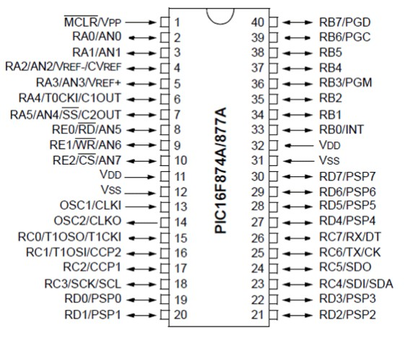

**Figure 1**: PIC16F877A

1. **Ultrasonic Sensor**Ultrasonic sensors help ROMOB move around safely by detecting obstacles. They work by sending out sound waves and measuring how long it takes for the echo to bounce back from nearby objects. This helps ROMOB know how far away things like walls or furniture are, so it can avoid bumping into them and plan its cleaning path smartly.  
   In this project, we use the HC-SR04 ultrasonic sensor to measure distance. It has four pins: two for power, one to send the sound (TRIG), and one to receive the echo (ECHO). The microcontroller sends a short signal to the TRIG pin, and the sensor sends out sound waves. When the waves bounce off an object and come back, the ECHO pin stays high for a short time. The microcontroller measures this time to figure out how far away the object is. This helps ROMOB clean more efficiently and avoid obstacles in real time.

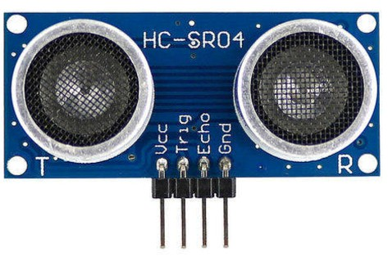

**Figure 2**: Ultrasonic Sensor

1. **Motor Drivers (H-Bridge)**The H-Bridge circuits are used in ROMOB to control the direction of the motors. They allow the motors to move both forward and backward, which is important for turning and moving in tight spaces. With the help of PWM (Pulse Width Modulation) signals from the microcontroller, we can also control the speed of the motors. This lets ROMOB adjust its movement smoothly, cover more area, and avoid obstacles effectively.  
   The H-Bridge makes the motor control reliable and stable, which is important for a robot that needs to move accurately. It also supports different motor setups, so we can easily adapt ROMOB to work on various surfaces and meet different cleaning needs.  
     
      
    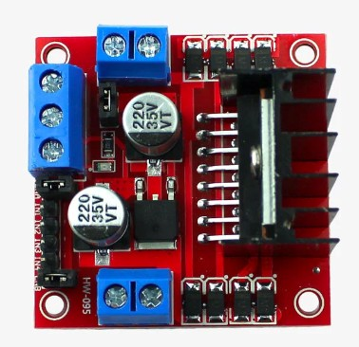

**Figure 3:** Motor Driver (H-Bridge)

1. **Fan**In the ROMOB cleaning robot, a 12V fan measuring 8×8 cm is used to create the suction needed to lift dust and dirt from the floor. It plays a key role in the vacuuming process. The microcontroller controls the fan’s speed using PWM signals, allowing the suction power to be adjusted depending on how much dirt is present. For example, higher speed can be used for dirtier areas, while lower speed helps save energy.  
   This control makes ROMOB more efficient and ensures it performs well on different floor types, keeping the suction strong and consistent.  
     
     
    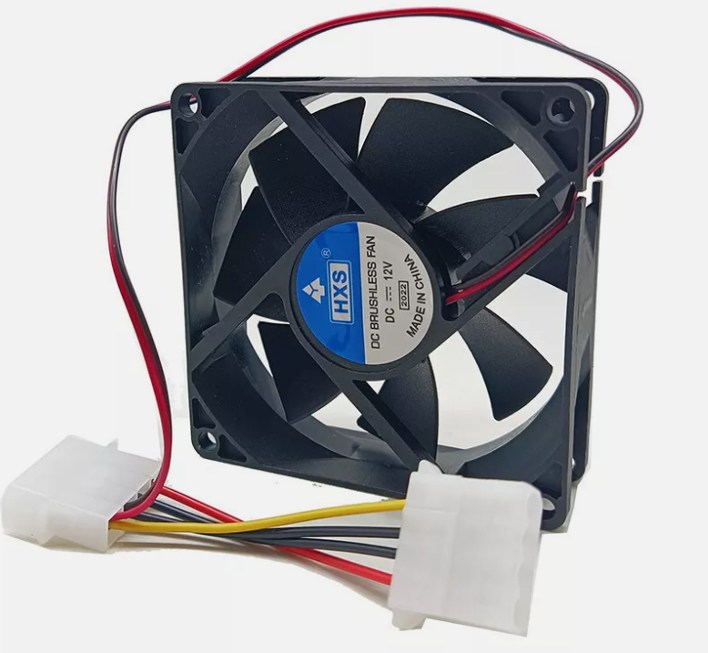

**Figure 4**: Fan

1. 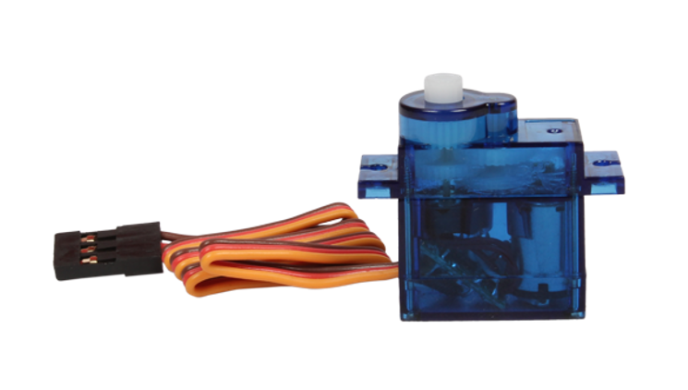**Servo Motor**We used a servo motor to control the movement of the mobile holder (mob). When the user doesn't need the holder, the servo motor lifts it up to keep it out of the way. When the user wants to use it, the motor lowers it to a convenient position for easy access. This allows for automatic adjustment based on the user's preference.

**Figure 5:** Servo Motor

1. **DC Motors (Two)**  
     
   We used two DC motors to drive the robot car, allowing it to move forward, backward, and turn. The motors are controlled by the PIC microcontroller, which receives distance data from the ultrasonic sensor. Based on this data, the PIC adjusts the movement of the car to avoid obstacles and navigate the environment efficiently.

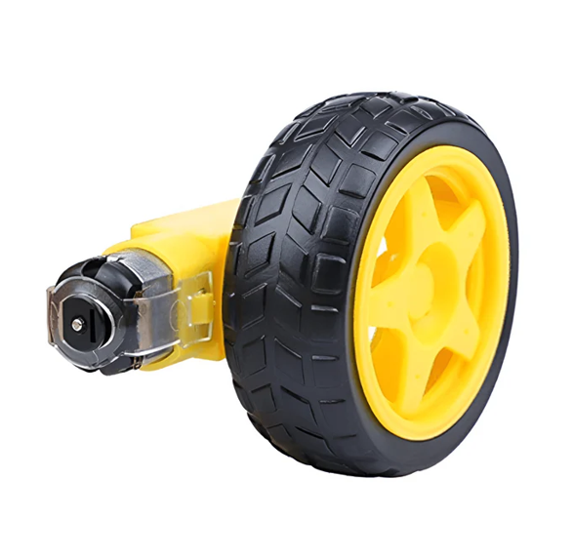

**Figure 6**: DC Motor

# Flow Chart

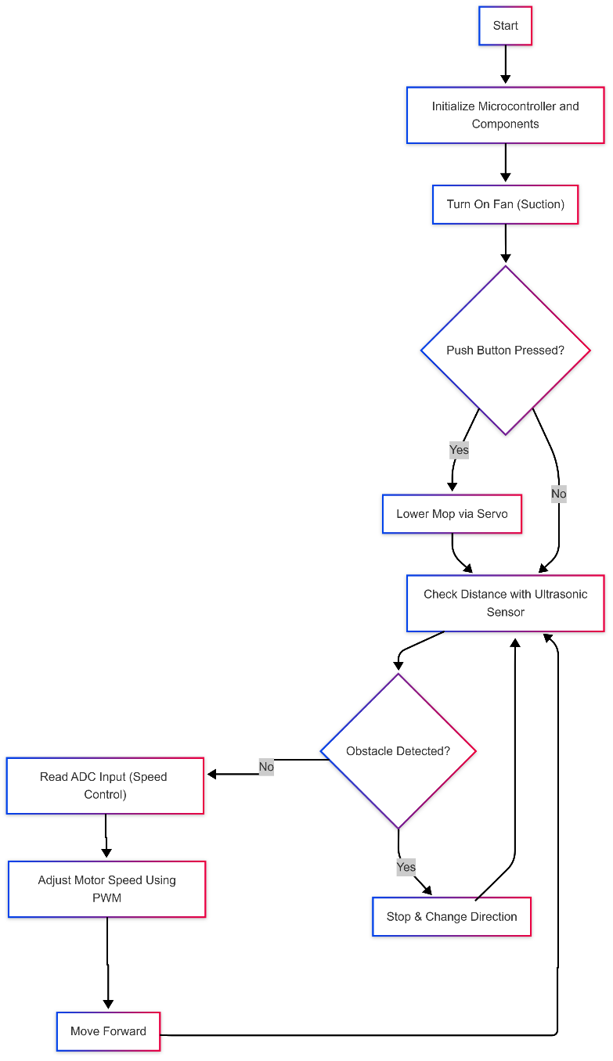

Figure 7: Flowchart

**Electrical Design**  
This schematic diagram illustrates the electrical design of our automated vacuum cleaner project. It shows how the PIC16F877A microcontroller interfaces with the DC motors, ultrasonic sensor, and power supply modules to enable coordinated control and navigation. An H-Bridge is used for precise bidirectional motor control, while the ultrasonic sensor provides reliable obstacle detection. The overall setup ensures efficient operation with streamlined connectivity. An 8MHz crystal oscillator is used to provide the necessary clock frequency for the microcontroller.  
  
 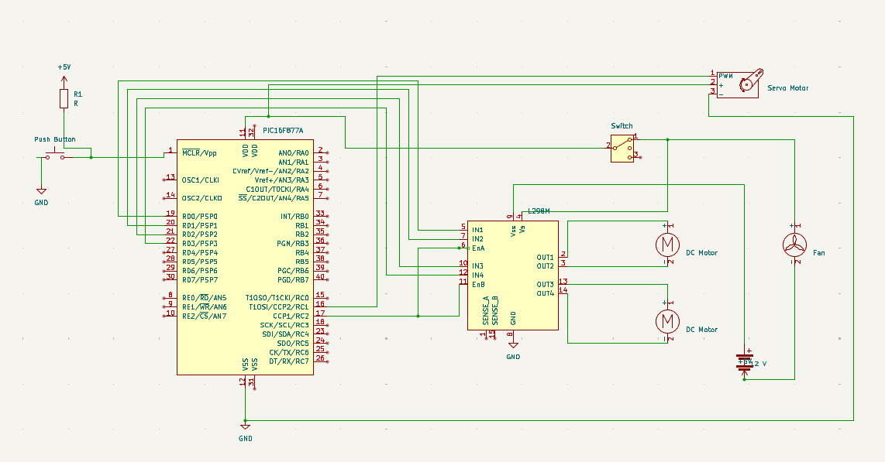

Figure 8: Schematic Design

Problems and SolutionsDuring the development and testing of the vacuum cleaner project, several key challenges arose. These issues were systematically addressed to enhance the system’s performance and ensure reliable operation:

1. Motor Speed Control:  
   Initially, the DC motors used in the vacuum cleaner were too powerful, resulting in excessive speed that affected maneuverability and stability. To solve this, the motor speed was reduced using PWM (Pulse Width Modulation) techniques, which provided finer control and smoother operation.
2. Servo Motor Integration:  
   Incorporating a servo motor alongside the DC motors, especially for directional control or sensing mechanisms, introduced complexity in timing and control logic. This was resolved by distributing the workload across two PIC16F877A microcontrollers: one dedicated to managing the main robot functions (movement, sensors, etc.) and another focused exclusively on controlling the servo motor. This division improved performance and reduced timing conflicts.
3. Ultrasonic Sensor Processing:Accurate distance sensing was critical for obstacle avoidance. To ensure reliable ultrasonic sensor readings, especially when used in tandem with other time-sensitive components like the servo motor, the dual-PIC approach was adopted. One PIC handled the ultrasonic data and robot control logic, while the second PIC ensured precise servo positioning, preventing interference and processing delays.

**Conclusion**  
The ROMOB project shows how we can build a smart cleaning robot using basic electronic components and a microcontroller. It can move on its own, avoid obstacles, and clean the floor using a vacuum fan. The PIC16F877A microcontroller controls all parts of the system. It turns on the fan at the start, controls the speed of the motors using an ADC signal, and uses an ultrasonic sensor to detect objects and avoid them.  
We also added a push button that lets the user lower the mop using a servo motor. This gives the robot the ability to clean in different ways. By using simple sensors and components, ROMOB can clean floors in an efficient and automatic way.  
This project helped us learn how to combine hardware and software in an embedded system. It is a good example of how microcontrollers can be used in real-life applications to solve everyday problems.

# **References**

[**https://ww1.microchip.com/downloads/en/devicedoc/39582b.pdf**](https://ww1.microchip.com/downloads/en/devicedoc/39582b.pdf)[**https://download.mikroe.com/documents/compilers/mikroc/pic/mi kroc-pic-manual-v101.pdf**](https://download.mikroe.com/documents/compilers/mikroc/pic/mikroc-pic-manual-v101.pdf)